Upload DQA Physics Report to MOSAIQ

# Purpose

This procedure describes how to upload a DQA Physics Report (from the Delta4 software) to MOSAIQ.

# Steps

1. Open the patient in MOSAIQ.
2. Click **Chart**.

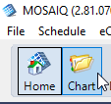

1. On the **Documents** tab, click **Add** > **eSCAN**.

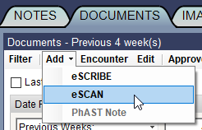

1. Navigate to the document’s location in the **Documents Available** window. Right click the document and click **Add**.

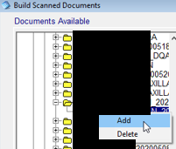

1. Set the **Document Type** to *P- Physics Report*, the **Encounter Date** to the date the QA was performed, and the reviewer to the onsite physicist.

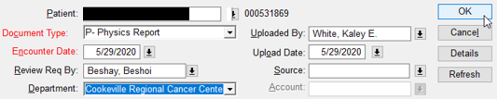

Ignore any warning about duplicate documents of the same type with the same encounter date:

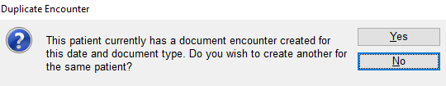

1. Highlight the document and click **Status**.

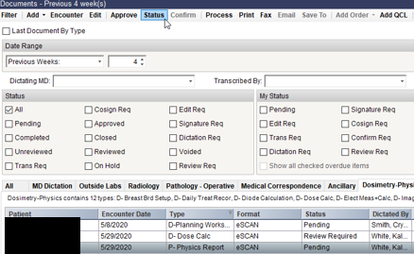

1. Select *Review Req* and enter your password.

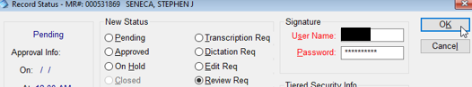

1. Note and complete the DQA QCL. The subject should be *DQA Passed*;the body should be the plan name. If it is an Elekta plan, also include the machine name(s).

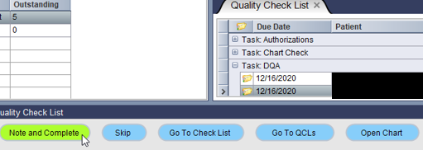

For a plan shot on E1 only:

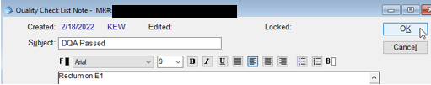

For a plan shot on both E1 and E2:

